**Project Title: Text Document Similarity Analysis using Vector Space Models**



**categorizing court judgments using cosine similarity**

Abstract: The increasing volume of court judgments poses significant challenges for legal practitioners in efficiently accessing relevant case precedents. This project aims to address this challenge by leveraging text similarity analysis techniques to categorize court judgments according to similar cases. The proposed approach involves preprocessing the textual content of court judgments, vectorizing them using TF-IDF, and calculating pairwise cosine similarity scores. Clustering algorithms are then applied to group similar judgments into distinct categories. The resulting clusters provide a structured representation of the legal corpus, enabling legal practitioners to quickly identify relevant case precedents and extract insights from large volumes of legal documents. The project contributes to enhancing legal research efficiency and supporting informed decision-making in the legal domain.

1. **Data Preprocessing**:
   * Read the court judgment data from the CSV file.
   * Preprocess the text data by removing stopwords, punctuation, and other irrelevant symbols.
   * Optionally, perform stemming or lemmatization to reduce words to their base form.
2. **Vectorization**:
   * Use a text vectorization technique such as TF-IDF to convert the preprocessed text data into numerical feature vectors.
   * Each court judgment will be represented as a TF-IDF vector in a high-dimensional vector space.
3. **Similarity Calculation**:
   * Compute pairwise cosine similarity between all pairs of court judgments based on their TF-IDF vectors.
   * Cosine similarity values range from -1 to 1, where higher values indicate greater similarity.
4. **Clustering**:
   * Apply a clustering algorithm such as K-means or hierarchical clustering to group similar court judgments together.
   * The number of clusters can be determined based on domain knowledge or using techniques such as silhouette score or elbow method.
5. **Evaluation and Analysis**:
   * Evaluate the quality of the clustering results using internal metrics such as silhouette score or external evaluation metrics if ground truth labels are available.
   * Analyze the clusters to understand the patterns and themes present in the court judgments within each cluster.
6. **Visualization**:
   * Visualize the clusters and their contents using techniques such as t-SNE (t-distributed Stochastic Neighbor Embedding) or PCA (Principal Component Analysis) for dimensionality reduction.
   * Visualizations can help in interpreting the clustering results and identifying any potential anomalies.
7. **Post-processing and Interpretation**:
   * Review the clustered court judgments within each category to verify the coherence of the clusters.
   * Assign meaningful labels or categories to the clusters based on the common themes or topics present in the judgments.

By following these steps, you can effectively categorize court judgments according to similar cases using cosine similarity. This approach can help in organizing and summarizing large volumes of legal documents, facilitating legal research, and assisting legal practitioners in identifying relevant case precedents.

Algebraic structure

In the context of abstract algebra(modern algebra), an algebraic structure refers to a set equipped with one or more operations that satisfy certain properties. These properties define how the elements of the set interact under those operations. Different types of algebraic structures arise based on the properties of these operations.

Some common algebraic structures include:

1. **Group**: Defined by a single binary operation that satisfies closure, associativity, identity element, and inverse element properties.
2. **Ring**: Defined by two binary operations (usually addition and multiplication) that satisfy closure, associativity, commutativity (for addition), distributivity, and the presence of an additive identity.
3. **Field**: Defined by two binary operations (usually addition and multiplication) that satisfy all the properties of a ring, with the additional property that multiplication is commutative and non-zero elements have multiplicative inverses.
4. **Vector Space**: Defined over a field, with additional operations of scalar multiplication and vector addition that satisfy various properties, such as closure, associativity, distributivity, and the presence of an additive identity.

These algebraic structures provide a framework for studying and understanding mathematical objects and their properties. They find applications in various branches of mathematics, physics, computer science, and other fields where abstract structures and their properties are analyzed and utilized.

**Vector Space:**

(A vector space over a field (such as the real numbers or complex numbers) is a set of vectors equipped with two operations)

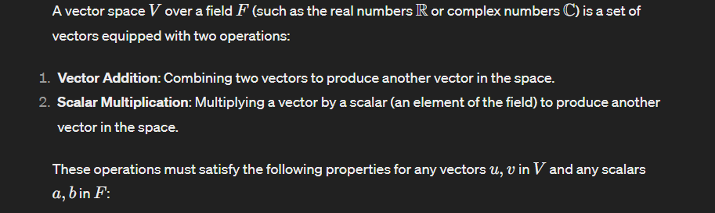

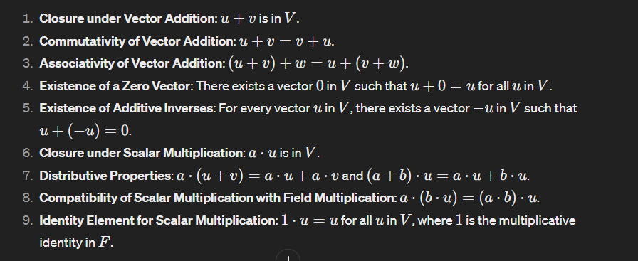

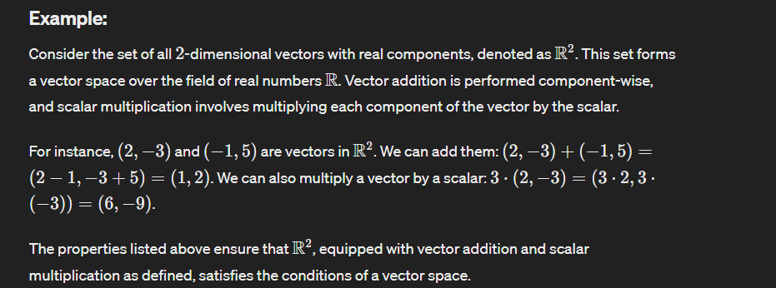

Where are we using these concept in our project

**1. Creating Vector Space**: The input documents are transformed into a vector space using the **TfidfVectorizer()** from scikit-learn. This vector space represents each document as a vector in a high-dimensional space, where each dimension corresponds to a unique term (word) in the corpus of documents. The value of each dimension in the vector represents the importance of that term in the document, typically calculated using TF-IDF (Term Frequency-Inverse Document Frequency) weighting.

(apart from TF-IDF, there are several other techniques commonly used to create vector space representations of text documents. Some of the popular methods include:

1. **Bag-of-Words (BoW)**:
   * BoW representation represents each document as a vector where each dimension corresponds to a unique term (word) in the entire corpus.
   * The value of each dimension in the vector represents the frequency of that term in the document (Term Frequency, TF).
   * BoW does not consider the order of words in the document, only their frequency.
2. **Word Embeddings**:
   * Word embeddings are dense, low-dimensional vector representations of words that capture semantic meaning.
   * Word embedding models such as Word2Vec, GloVe (Global Vectors for Word Representation), and FastText learn distributed representations of words based on their context in large text corpora.
   * Each word in the vocabulary is represented as a fixed-length dense vector, and documents are represented by averaging or concatenating the word vectors of their constituent words.
3. **Doc2Vec (Paragraph Vectors)**:
   * Doc2Vec extends Word2Vec to learn distributed representations of entire documents.
   * It represents each document as a fixed-length dense vector, similar to word embeddings.
   * Doc2Vec learns document embeddings by predicting the context words within the document, capturing the document's semantic meaning.
4. **Sentence Embeddings**:
   * Similar to word embeddings, sentence embeddings represent entire sentences as dense vectors.
   * Techniques such as Universal Sentence Encoder (USE) and Sentence-BERT (SBERT) learn representations of sentences by encoding their semantic meaning.
   * These embeddings are useful for tasks such as semantic similarity, text classification, and information retrieval.

)

Mathematical concept:  
TF-IDF (Term Frequency-Inverse Document Frequency) is a numerical statistic used in information retrieval and text mining to evaluate the importance of a term in a document relative to a corpus of documents. Here's the mathematical explanation of how TF-IDF is calculated:

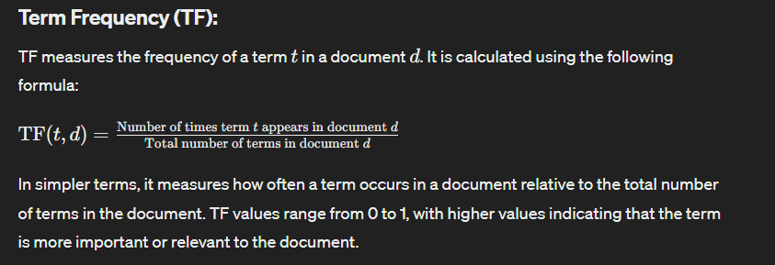 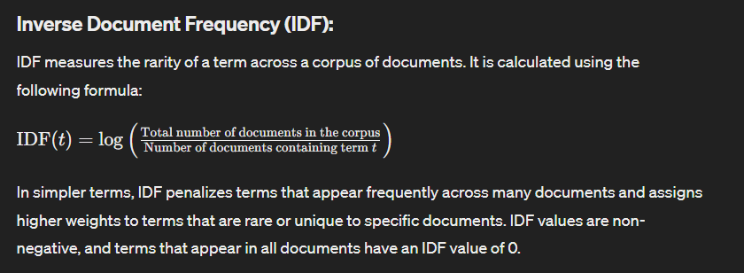

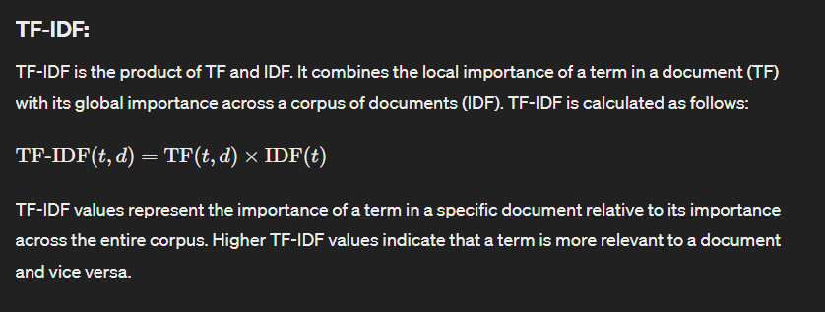

**Implementation in TfidfVectorizer:**

The **TfidfVectorizer** in scikit-learn implements TF-IDF vectorization for a given corpus of documents. It preprocesses the text data, computes the TF and IDF values for each term, and generates TF-IDF vectors for each document in the corpus. These vectors are normalized to unit length to ensure that each document's representation is comparable in terms of magnitude. The resulting TF-IDF matrix represents the entire corpus in the vector space.

1. **Computing Cosine Similarity**: Once the vector space representation is obtained, cosine similarity is calculated between pairs of documents. Cosine similarity measures the cosine of the angle between two vectors in the vector space. It ranges from -1 (completely dissimilar) to 1 (completely similar), with 0 indicating no similarity. Cosine similarity is computed efficiently using vector operations and is commonly used in text similarity tasks because it is insensitive to the magnitude of the vectors and focuses on their direction.

Cosine similarity is a measure used to determine how similar two vectors are irrespective of their magnitudes. It calculates the cosine of the angle between two vectors in a multidimensional space. The mathematical branch behind cosine similarity is primarily trigonometry and linear algebra.

**Trigonometry:**

The cosine similarity metric utilizes concepts from trigonometry to measure the cosine of the angle between two vectors. In trigonometry, the cosine of an angle is defined as the ratio of the adjacent side to the hypotenuse in a right triangle. In the context of vectors, the cosine of the angle between two vectors is calculated based on their dot product and magnitudes.

**Linear Algebra:**

Cosine similarity is closely related to vector operations and concepts from linear algebra. Key concepts include:

1. **Vector Operations**: Cosine similarity involves vector operations such as dot product and vector magnitude.

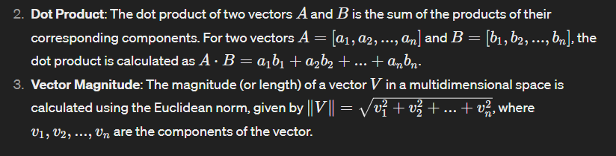

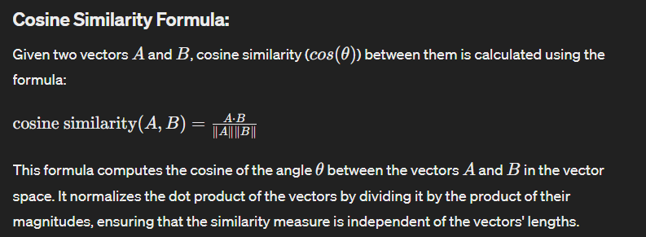

Overall, cosine similarity leverages mathematical concepts from trigonometry and linear algebra to quantify the similarity between vectors in a multidimensional space. It is a widely used metric in various fields, including information retrieval, natural language processing, and machine learning.

(  
In addition to cosine similarity, several other methods and metrics can be used to find the similarity between texts. Some common alternatives include:

1. **Jaccard Similarity**:
   * Jaccard similarity measures the similarity between two sets by comparing their intersection and union.
   * It is calculated as the size of the intersection divided by the size of the union of the sets.
   * Jaccard similarity is particularly useful when dealing with sets of words or tokens, such as in document classification or clustering tasks.
2. **Euclidean Distance**:
   * Euclidean distance measures the straight-line distance between two points in a multidimensional space.
   * In the context of text similarity, Euclidean distance can be calculated between the vector representations of two documents.
   * However, Euclidean distance does not account for the direction of the vectors and may not be suitable for high-dimensional sparse data like text.
3. **Manhattan Distance**:
   * Manhattan distance, also known as city block distance or L1 distance, measures the sum of the absolute differences between the coordinates of two points.
   * Similar to Euclidean distance, Manhattan distance can be calculated between vector representations of documents.
   * It is less affected by outliers compared to Euclidean distance but may not capture the underlying structure of the data as effectively.
4. **Cosine Similarity with Word Embeddings**:
   * Instead of using traditional vector space models like TF-IDF, cosine similarity can also be computed using word embeddings such as Word2Vec or GloVe.
   * Word embeddings capture the semantic meaning of words and can provide more context-aware similarity measures compared to bag-of-words models.
   * Cosine similarity with word embeddings is particularly useful for tasks like semantic similarity and information retrieval.
5. **Word Mover's Distance (WMD)**:
   * Word Mover's Distance calculates the minimum amount of "work" required to transform one set of word vectors into another.
   * It considers the semantic similarity between individual words and their respective distances in the embedding space.
   * WMD is computationally expensive but can provide more nuanced similarity measures compared to simpler methods.

These methods offer different perspectives on text similarity and may be more suitable for specific tasks or datasets. The choice of similarity metric depends on factors such as the nature of the text data, the desired level of granularity in similarity measurement, and computational considerations.

)